Frame

Jacob Hawley

I will be working on the frame of the bike. The frame is the skeleton of the bike and will support the load of the outer shell, interior components, and the driver of the bike. The two engineering principles I will be looking at are force distribution and centre of mass.

For **force distribution** I will be looking at the placement of the two front wheels. Whether the wheels will be in front of the pedals or behind them, and how this will affect the ride.

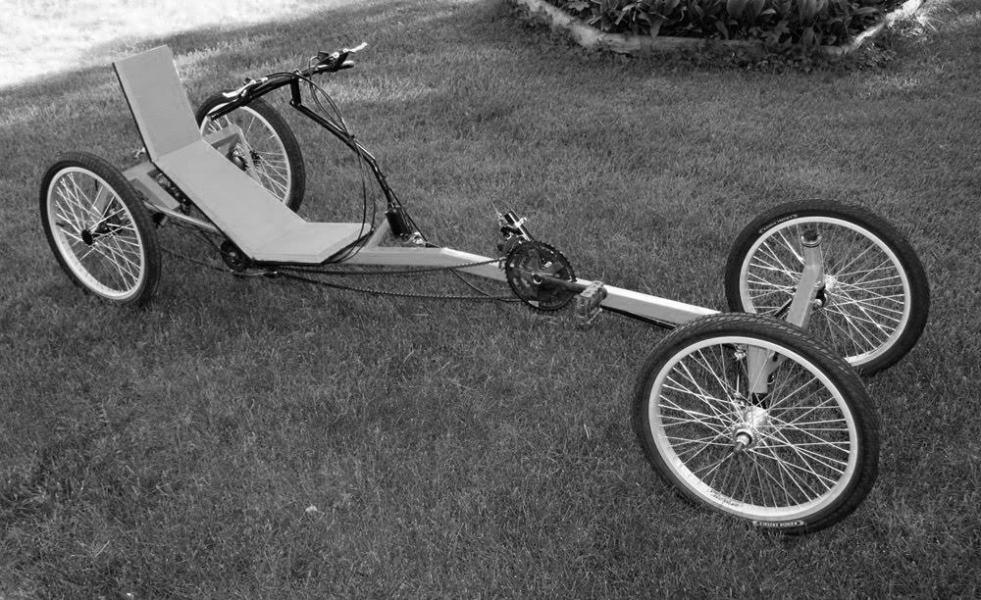

Atomic Zombie Extreme. (2010, June 1). New StreetFighter Recumbent Quad Cycle [Online]. Available: http:// www.blogspot.com

For the **centre of mass** I will try to find an ideal height for the seat to be off the ground. The seat must be high enough that it will not get in the way while riding through snow and other terrains, but still be low enough to not cause a problem with stability.

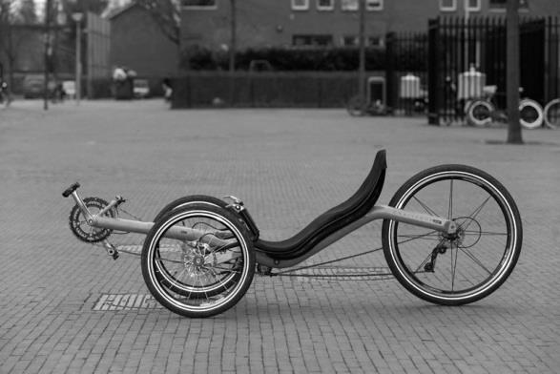

Radical Brad. (2009, July210). Warrior Racing Trike Build [Online]. Available: http//www.forum.atomiczombie.com